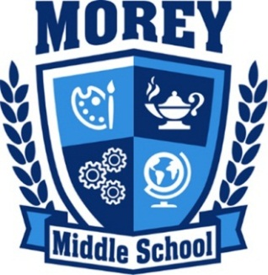

AFTER SCHOOL CLUBS
PAYMENT PLAN & SCHOLARSHIP REQUEST FORM
2016-2017

No Student Will Be Turned Away Due to Inability to Pay!

Student Name: Student ID #:

Parent/Guardian Name:

The Registration Fee to participate in After School Clubs is $75/semester ($150/year).
Please briefly explain why payment of the full Registration Fee would be a hardship:

Which reason(s) best describes why you want your student to participate in After School Clubs:

□Relationships with students/staff □Enrichment opportunities □General supervision

Registration Form Required: A Morey After School Registration Form (bright green) must be submitted in order to participate in After School clubs. Forms are available in Room 134.

Payment Plan:

Please mark the amount you will pay and the date:
□ $75 □ $50 □ $25 □ $15 □ $10 □ $5 Date you will make payment: ________

Please mark the amount you will pay and the date:
□ $75 □ $50 □ $25 □ $15 □ $10 □ $5 Date you will make payment: ________

Please mark the amount you will pay and the date:
□ $75 □ $50 □ $25 □ $15 □ $10 □ $5 Date you will make payment: ________

____________________________________ ___________________
Parent/Guardian Signature Date

Need later coverage for your student?
- Morey Neighborhood Center offers FREE activities from 4:15-7:30 pm on Mondays & Wednesdays.
- Boys & Girls Club (Cope Branch) is available for FREE until 9 pm M-F, with free transportation from Morey. Registration required.
Meryl Icove, Coordinator
After School Clubs & Morey Neighborhood Center
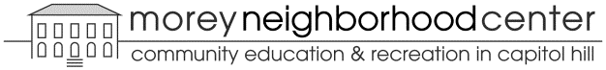

Morey Middle School, Room 134
720.424.0791
Meryl_Icove@dpsk12.org
http://mnc.dpsk12.org/afterschool

