MOREY AFTER SCHOOL CLUBS SCHEDULE – Winter 2017
Monday, 3:15-4:15pm  Academic Zone – (Homework Help, Tutoring, Board Games, Magic Cards, Chess) – Linnie Roy, Library  Sports Zone – Kelly Wright, Meet in Room 134  Minecraft Club – Kim Henderson, Room 106  Art Club – Jake Anderson, Room 109  Mathletics/Math Counts Club – Alisha Janes, Room 120  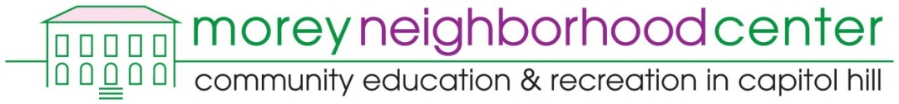  Morey Neighborhood Center provides FREE recreational activities  for youth inside Morey Middle School.  Mondays & Wednesdays, 4:15 – 7:15 pm | Tuesday, 3:15-4:15pm  Academic Zone – (Homework Help, Tutoring, Board Games, Magic Cards, Chess) – Linnie Roy, Library  Sports Zone – Kelly Wright, Meet in Room 134  Robotics Club – Kane Jessen, Room 106 (3:15-4:45 pm)  Running Club – Alisha Janes/Darcy Barr, Room 120 | Wednesday, 3:15-4:15pm  Swim Club (Open swim) – Gabby Lopez, Meet in Room 134  Sports Zone – Demond Perris, Meet in Room 134  Gardening & Cooking Club – Gigia Kolouch, Room 115 (3:15-4:45 pm)  A Morey After School Registration Form (bright green) is required in order to participate in After School Clubs. The fee for After School Clubs is $75 per semester.  No student will be turned away due to inability to pay.  Payment Plan & Scholarship Forms are available in Room 134. | Thursday, 3:15-4:15pm  Academic Zone – (Homework Help, Tutoring, Board Games, Magic Cards, Chess) – Linnie Roy, Library  Sports Zone – Kelly Wright, Meet in Room 134  Drama/Improv Club – Allison Learned, Auditorium
Updated 1-26-17
Meryl Icove, Coordinator, Room 134
Morey After School Clubs & Morey Neighborhood Center
meryl_icove@dpsk12.org 720-424-0791

