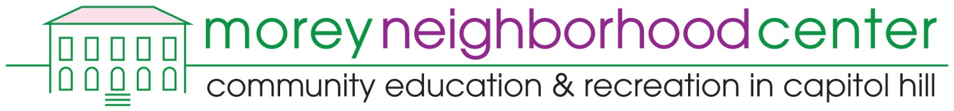

AFTER SCHOOL PROGRAM REGISTRATION FORM 2017-2018

SCHOOL ATTENDING (PLEASE CIRCLE): MOREY MIDDLE SCHOOL DSISD

STUDENT |  | INFORMATION
First Name |  | Last Name  Student ID #:
Address |  |  |  | Grade (circle)  6 7 8 9 10 11 | Date of Birth  Month Day Year
City |  |  | State | Zip | Identified Gender
Student’s Cell Phone # |  |  | Student’s E-mail:
Ethnicity | African American/Black | American Indian |  | Asian/Pacific Islander |  | Caucasian/White
 | Hispanic/Latina | Other:

neenPARENT/GUARDIAN INFORMATION (First emergency contact)
First Name | Last Name
Address |  |  | Apt #
City |  | State | Zip
Cell #  Home #  Work # | Parent E-mail:

SECOND EMERGENCY CONTACT (different from above)
Emergency Contact Name:
Address |  |  | Apt#
City |  | State | Zip
Phone# | E-mail

Special Needs |  |  | Wheel Chair Accessibility | Language Assistance | Other (please explain)
Do you have any illnesses, allergies, medical problems, or other conditions that Morey Neighborhood Center staff will need to know about in order to keep you safe during the program?
Yes | No | Describe:  If yes, Doctor’s Name & Phone Number:

TURN OVER →
PARTICIPANT AGREEMENT

In consideration of the benefits to be received, and in view of the fact that Morey Neighborhood Center (MNC) will be caring for my child(ren) while providing educational and recreational programs and that membership is voluntary, and having confidence that every precaution will be taken to ensure the safety and wellbeing of my child(ren), I agree to my child(ren)’s participation in the activities as follows:
Liability and Medical Emergency: I understand that the registered activities and services may have an element of hazard and inherent danger and I take full responsibility for the actions and physical condition of myself or my child(ren). I agree to indemnify and hold harmless the Denver Public Schools, and the City and County of Denver and their employees from liability, loss, cost, or expenses that my child(ren) may incur while participating in activities. I understand if my child(ren) has health problems, I must inform the Coordinator before participation in any activity. In the event of serious illness or injury to my child(ren), I will allow transportation to the nearest hospital by an ambulance. I hereby give my permission for MNC to secure medical and/or surgical treatment for my child(ren), and I will accept all expenses of such care.
Pupil Record Release: I hereby give permission to the Denver Public Schools (DPS) to release educational records (including but not limited to attendance records, grades, current skill test results, and suspension records) to MNC program staff for the purposes of evaluating the success of the program and to be able to more effectively serve my child. I understand that these records are confidential, and will not be used for any other purpose or released to any other person or agency without my written consent.
Photo Release: I hereby give full consent to MNC and parties designated by MNC to photograph or publish any photographs or videos taken by them in which I or my child(ren) appears. I agree that photos may be used for public display and/or publication.
Behavior and Expectations: I and/or my child(ren) understand that all policies and procedures of the Board of Education for DPS must be adhered to during all MNC activities both on school property in alternate locations (field trips). I acknowledge that if I or my child(ren) does not abide by the rules established by DPS and Morey Neighborhood Center, I or my child(ren) may no longer be eligible to participate in the program.

Fees: $100 per semester/$200 per year
Families with an inability to pay the full fee must apply to Morey Neighborhood Center for a scholarship.

Student Agreement
I agree to comply with all relevant Morey Neighborhood Center rules and policies.

_________________________________________________ ________________________
Signature of Student Date

MOREY STUDENTS ONLY:
Parent Agreement
I have read all the information above and fully understand and agree to the contents.

_____________________________________________ _____________________________________________
Please print name of Parent/Guardian Relationship to Participant

_________________________________________________ ________________________
Signature of Parent/Guardian Date

For office use only: School (circle): Morey DSISD
Payment Date: __________ Method (circle): Cash Check (# ___________ ) Amount: $____________
Payment Date: __________ Method (circle): Cash Check (# ___________ ) Amount: $____________
Scholarship Request: _______

